Statistical analysis - Mattan Ben-Shachar

Distraction and Suppression in ADHD project

**Summary**

The current study attempts to disentangle potential differences in initial distraction by salient distractors and suppression of these distractors following repeated exposure, between adults with and adults without ADHD. To do so, we will rely on the additional singleton paradigm, where participants search for a predefined target shape (a circle within heterogeneous distractors) and a salient distractor, a color singleton, appears on half of the trials (see figure 1). The experiment will be divided into two sessions, each containing three blocks, with the singleton color remaining constant in each block of trials, but changes to a new color at the beginning of each block. Initial distractor interference, measured by difference between distractor-present and -absent trials before suppression emerges, will index **baseline distractibility**. The decline in distractor interference following a repeated exposure to the distractor will index **suppression efficiency**. Of main interest here is whether participants with ADHD will show different patterns of baseline distractibility and suppression efficiency relative to control participants.

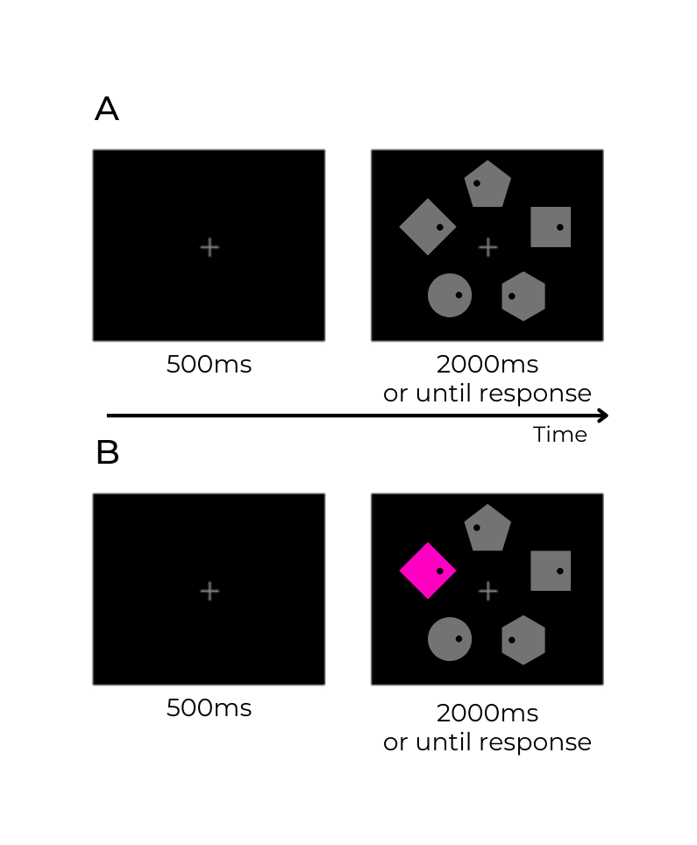

*Figure 1.* Sample of trial sequence. Participants will be instructed to search for a target shape (the circle) and report the location of the dot inside it (either left or right). (A) Sample distractor-absent trial. (B) Sample distractor-present trial. The color of the singleton distractor will change on each block.

**Pilot data**

A pilot experiment was conducted on 8 neurotypical (control) participants. Originally, we used a split-block analysis to assess baseline distractibility as distractor interference during the first halves of the blocks, and suppression efficiency as the difference in the magnitude of distractor interference during the first and the second block halves.

To evaluate suppression efficiency, we used a 2x2 repeated measures ANOVA on log RTs, with block half (first vs. second half of each block, collapsed across all six blocks) and distractor presence (present vs. absent). Critically, we found a two-way interaction between block half and distractor presence, F(1, 7)=7.41 , p<.03, indicating that distractor interference was greater in the first but not the second halves of the blocks (see figure 2).

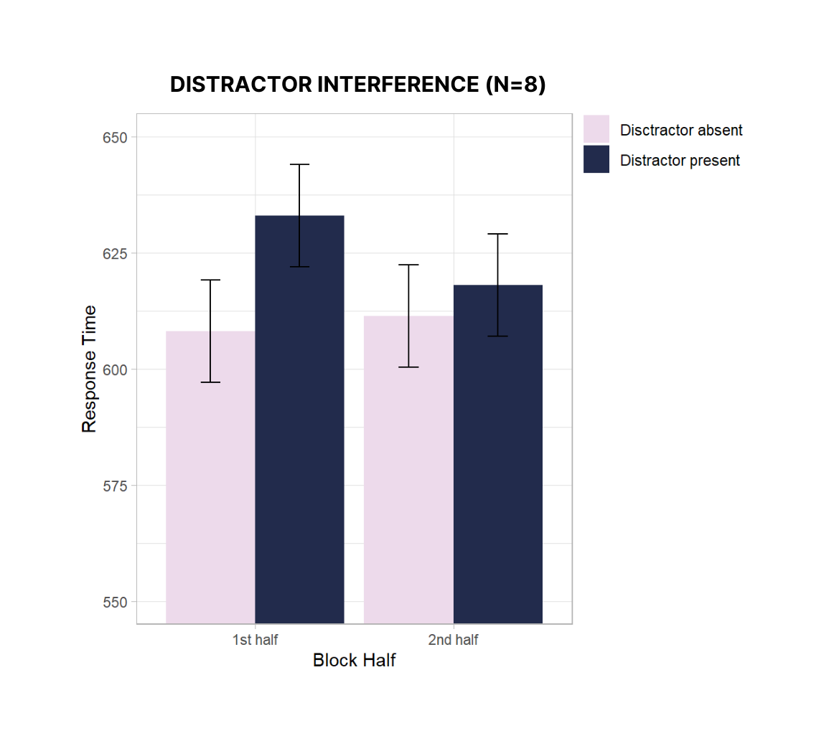

*Figure 2.* Response time as a function of block half (first vs. second) and distractor presence (present vs. absent) across all six blocks of the pilot experiment. Distractor interference was greater in the first, but not the second halves of the blocks.

**Analysis schedule**

1. Bayesian analysis based on hierarchical model that includes distractor presence (condition), trials (instead of block half), and a trial by condition interaction.
2. Reliability between the two sessions using the correlation of the random effect.
3. Distinguishing between mew and tau parameters using Ex-Gaussian distribution to assess individual variance.